CYCLE-1

1. **Program to Print all non-Prime Numbers in an Interval.**

print("SJC22MCA-2053 \nSREELAKSHMI M \nMCA 2022-2024 \nOutput: ")

start=int(input("Enter the starting number:"))

end=int(input("Enter the ending number:"))

print("Non-prime numbers in the intervel",start,"to",end,"are:")

for num in range(start,end + 1):

if num > 1:

for i in range(2, num):

if(num % i) == 0:

break

else:

continue

print(num,end=' ')

**OUTPUT**

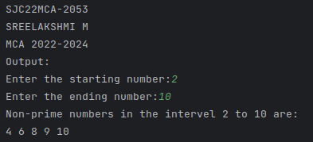

1. **Program to print the first N Fibonacci numbers.**

print("SJC22MCA-2053 \nSREELAKSHMI M \nMCA 2022-2024 \nOutput: ")

n=int(input("Enter the number of Fibonacci numbers to print:"))

a=0

b=1

for i in range(0,n):

print(a,end=" ")

c=a+b

a=b

b=c

**OUTPUT**

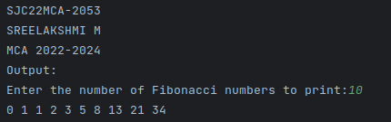

1. **Given sides of a triangle, write a program to check whether given triangle is an isosceles, equilateral or scalene.**

print("SJC22MCA-2053 \nSreelakshmi M \n2022-2024 \nOutput:")

print("Input lengths of the triangle sides: ")

x = float(input("x: "))

y = float(input("y: "))

z = float(input("z: "))

if x == y == z:

print("Equilateral triangle")

elif x==y or y==z or z==x:

print("isosceles triangle")

else:

print("Scalene triangle")

**OUTPUT**

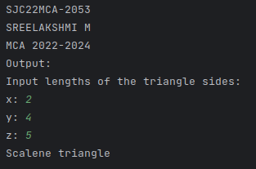

1. **Program to check whether given pair of number is coprime.**

import math

print("SJC22MCA-2053 \nSREELAKSHMI M \nMCA 2022-2024 \nOutput: ")

num1 = int(input("Enter the first number:"))

num2 = int(input("Enter the second number:"))

gcd = math.gcd(num1, num2)

if gcd == 1:

print(f"{num1} and {num2} are coprime.")

else:

print(f"{num1} and {num2} are not coprime. Their GCD is {gcd}.")

**OUTPUT**

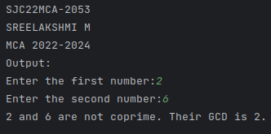

1. **Program to find the roots of a quadratic equation(rounded to 2 decimal places).**

import cmath

print("SJC22MCA-2053 \nSREELAKSHMI M \nMCA 2022-2024 \nOutput: ")

a=float(input("Enter number a:"))

b=float(input("Enter the number b:"))

c=float(input("Enter the number c:"))

d=(b**2) - (4*a*c)

sol1=(-b-cmath.sqrt(d))/(2*a)

sol2=(-b+cmath.sqrt(d))/(2*a)

print("The solution are {0} and {1}".format(sol1,sol2))

**OUTPUT**

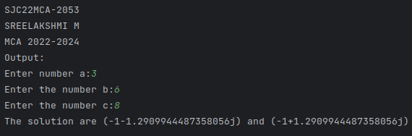

1. **Program to check whether a given number is perfect number or not(sum of factors =number).**

print("SJC22MCA-2053 \nSREELAKSHMI M \nMCA 2022-2024 \nOutput: ")

num = int(input("Enter a number: "))

sum_of_factors = 0

for i in range(1,num):

if num % i == 0:

sum_of_factors += i

if sum_of_factors == num:

print("The entered number is a perfect number")

else:

print("The entered number is not a perfect number")

**OUTPUT**

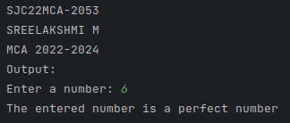

1. **Program to display amstrong numbers upto 1000.**

print("SJC22MCA-2053 \nSREELAKSHMI M \nMCA 2022-2024 \nOutput: ")

for num in range(1, 1001):

order = len(str(num))

sum = 0

temp = num

while temp > 0:

digit = temp % 10

sum += digit ** order

temp //= 10

if num == sum:

print(num)

**OUTPUT**

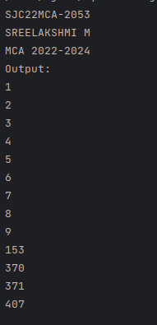

1. **Store and display the days of a week as a List, Tuple, Dictionary, Set. Also**

**demonstrate different ways to store values in each of them. Display its type also.**

print("SJC22MCA-2053 \nSREELAKSHMI M \nMCA 2022-2024 \nOutput: ")

days_list = ["Monday", "Tuesday", "Wednesday", "Thursday", "Friday", "Saturday", "Sunday"]

print("List of days:", days_list)

print("Type of days_list:", type(days_list))

days_tuple = ("Monday", "Tuesday", "Wednesday", "Thursday", "Friday", "Saturday", "Sunday")

print("\nTuple of days:", days_tuple)

print("Type of days_tuple:", type(days_tuple))

days_dict = {

1: "Monday",

2: "Tuesday",

3: "Wednesday",

4: "Thursday",

5: "Friday",

6: "Saturday",

7: "Sunday"

}

print("\nDictionary of days:", days_dict)

print("Type of days_dict:", type(days_dict))

days_set = {"Monday", "Tuesday", "Wednesday", "Thursday", "Friday", "Saturday", "Sunday"}

print("\nSet of days:", days_set)

print("Type of days_set:", type(days_set))

**OUTPUT**

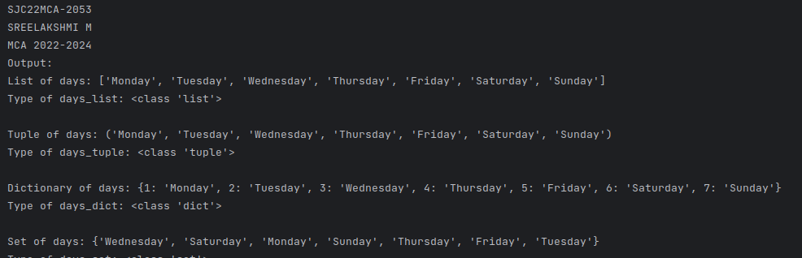

1. **Write a program to add elements of given 2 lists.**

print("SJC22MCA-2053 \nSREELAKSHMI M \nMCA 2022-2024 \nOutput: ")

def add_lists(list1, list2):

if len(list1) != len(list2):

return None

result_list = [a + b for a, b in zip(list1, list2)]

return result_list

list1 = input("Enter elements for the first list (comma-separated): ").split(',')

list1 = [int(x) for x in list1]

list2 = input("Enter elements for the second list (comma-separated): ").split(',')

list2 = [int(x) for x in list2]

result = add_lists(list1, list2)

if result:

print("Resultant list after addition:", result)

else:

print("Lists are of different lengths. Addition not possible.")

**OUTPUT**

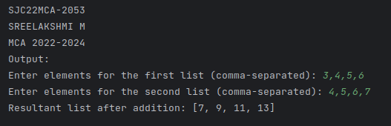

1. **Write a program to find the sum of 2 matrices using nested List.**

print("SJC22MCA-2053 \nSREELAKSHMI M \nMCA 2022-2024 \nOutput: ")

rows = int(input("Enter the number of rows: "))

cols = int(input("Enter the number of columns: "))

matrix1 = []

matrix2 = []

print("Enter elements for the first matrix:")

for i in range(rows):

row = []

for j in range(cols):

element = int(input(f"Enter element at position ({i+1},{j+1}): "))

row.append(element)

matrix1.append(row)

print("Enter elements for the second matrix:")

for i in range(rows):

row = []

for j in range(cols):

element = int(input(f"Enter element at position ({i+1},{j+1}): "))

row.append(element)

matrix2.append(row)

result_matrix = []

for i in range(rows):

row = []

for j in range(cols):

sum_element = matrix1[i][j] + matrix2[i][j]

row.append(sum_element)

result_matrix.append(row)

print("The sum of the two matrices is:")

for i in range(rows):

for j in range(cols):

print(result_matrix[i][j], end=" ")

print()

**OUTPUT**

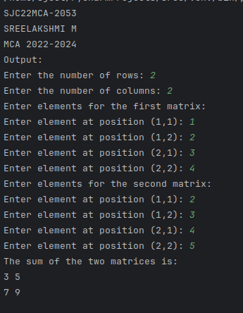

1. **Write a program to perform bubble sort on a given set of elements.**

print("SJC22MCA-2053 \nSREELAKSHMI M \nMCA 2022-2024 \nOutput: ")

def bubble_sort(arr):

n = len(arr)

for i in range(n):

for j in range(0, n - i - 1):

if arr[j] > arr[j + 1]:

arr[j], arr[j + 1] = arr[j + 1], arr[j]

elements = input("Enter elements separated by spaces: ").split()

elements = [int(e) for e in elements]

print("Original array:", elements)

bubble_sort(elements)

print("Sorted array:", elements)

**OUTPUT**

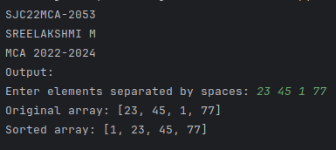

1. **Program to find the count of each vowel in a string(use dictionary).**

print("SJC22MCA-2053 \nSREELAKSHMI M \nMCA 2022-2024 \nOutput: ")

se=input("enter the sentence:");

string=se.lower()

print(string)

count=0

list1=["a","e","i","o","u"]

for char in string:

if char in list1:

count=count+1

print("number of vowels",count)

**OUTPUT**

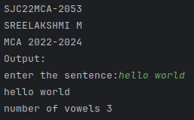

1. **Write a Python program that accept a positive number and subtract from this number the sum of its digits and so on. Continues this operation until the number is positive**

def sum_of_digits(n):

digit_sum = 0

while n > 0:

digit_sum += n % 10

n //= 10

return digit_sum

try:

print("SJC22MCA-2053\nSREELAKSHMI M\nMCA 2022-2024\nOutput:")

num = int(input("Enter a positive number: "))

if num <= 0:

print("Please enter a positive number.")

else:

while num > 0:

digit_sum = sum_of_digits(num)

print(f"{num} - {digit_sum} = {num - digit_sum}")

num -= digit_sum

except ValueError:

print("Invalid input. Please enter a valid positive number.")

**OUTPUT**

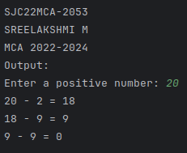

1. **Write a Python program that accepts a 10 digit mobile number, and find the digits which are absent in a given mobile number.**

def find_absent_digits(mobile_number):

all_digits = set("0123456789")

mobile_digits = set(mobile_number)

absent_digits = all_digits - mobile_digits

return sorted(list(absent_digits))

try:

print("SJC22MCA-2053\nSREELAKSHMI M\nMCA 2022-2024\nOutput:")

mobile_number = input("Enter a 10-digit mobile number: ")

if len(mobile_number) == 10 and mobile_number.isdigit():

absent_digits = find_absent_digits(mobile_number)

if absent_digits:

print("Absent digits in the mobile number:", ', '.join(absent_digits))

else:

print("The mobile number contains all digits from 0 to 9.")

else:

print("Invalid input. Please enter a valid 10-digit mobile number.")

except ValueError:

print("Invalid input. Please enter a valid 10-digit mobile number.")

**OUTPUT**

